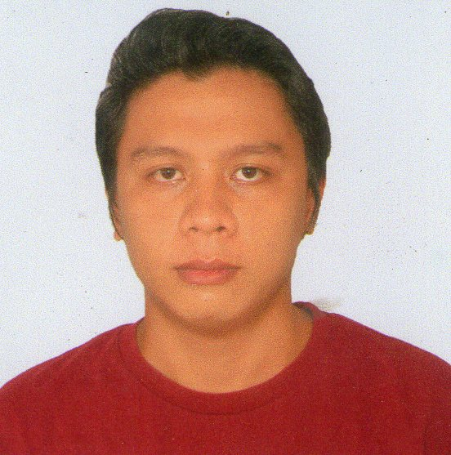 | Gerardo B. Retubado Jr.
Zone Camansi, Paknaan, Mandaue City, Cebu 6014
(032)505-3675 / 09079499865
ev.gerardo5294@gmail.com
CAREER OBJECTIVES
- To become part of globally competitive individuals.

PERSONAL INFORMATION
Birth date: June 07, 1991
Nationality: Filipino
Birthplace: Opao, Mandaue City
Height: 5’5’’
Weight: 60 Kgs.
WORK EXPERIENCE:

Measuring Technician
Microsourcing International Limited
12th Floor TGU Tower, Cebu IT Park Lahug, Cebu City 6014
February 2012 - June 2012

SKILLS

- Internet savvy
- Good Intrapersonal Skills
- Microsoft Office Package

INTEREST AND ACTIVITIES

- Online Gaming
- Listening Music
- Watching Movies

EDUCATIONAL ATTAINMENT:

College: Saint Paul College Foundation Inc.
2 year Computer Programming
Hi-way Seno, Mandaue City
2009-2011

Secondary: Don Gerardo Ll. Ouano Memorial National Highschool
Opao, Mandaue City
2004-2008

Elementary: Opao Elementary School
Opao Mandaue City
1998-2004

CHARACTER REFERENCES:

Mr. Aaron Mejares
Chemist
University of San Carlos (Talamban Campus)
Talamban, Cebu City
09324551518

